Team Silver - 5/4/2025 - CSD-310

Tyson B.

Crytal L.

Rashai R.

Milestone #2

Revised ERD:

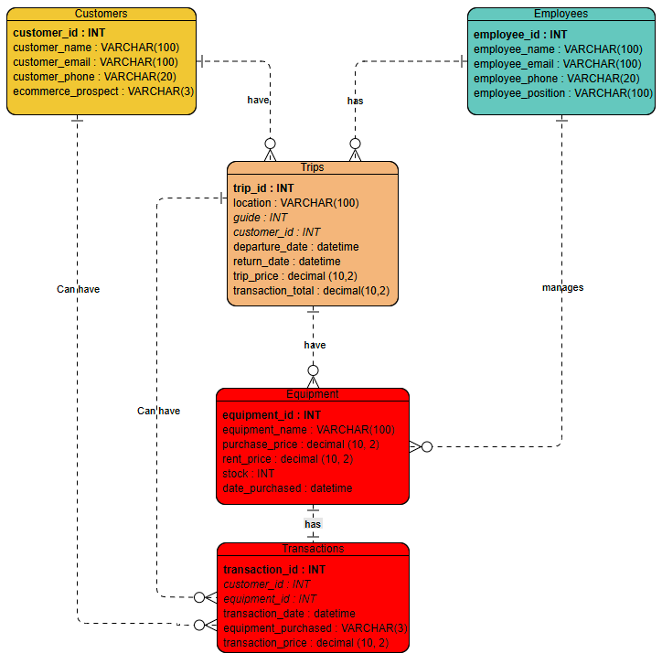

SQL TABLE:

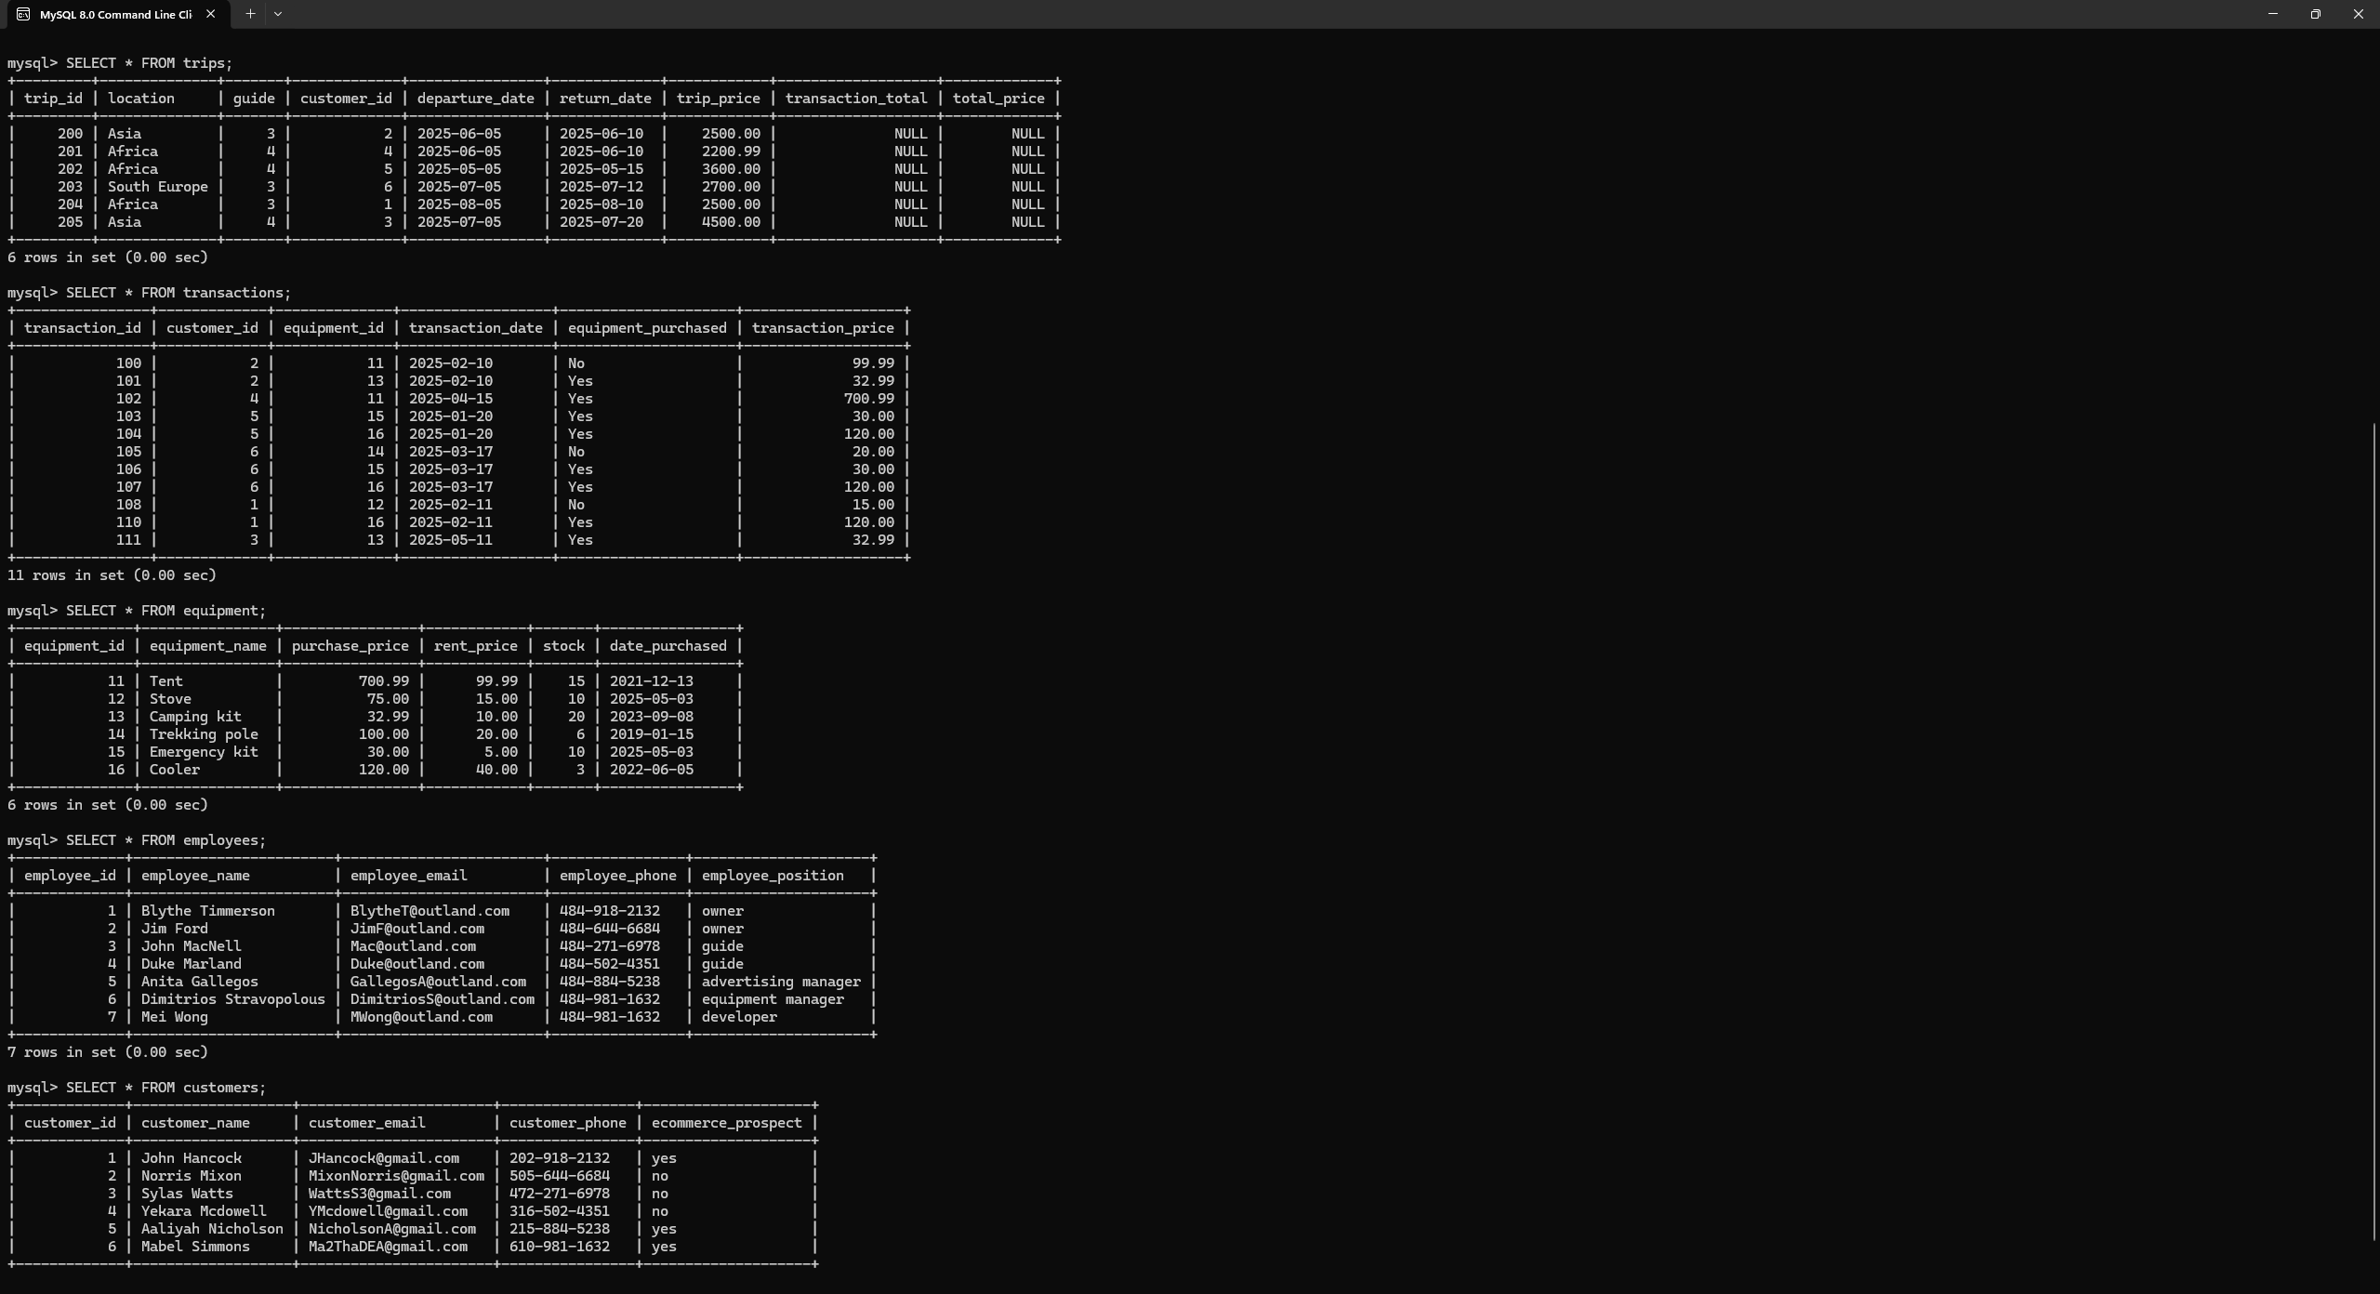

Python Data:

